Project Development Phase
Model Performance Test

Date | 23 June 2025
Team ID | LTVIP2025TMID38618
Project Name | Revolutionizing Liver Care : Predicting Liver Cirrhosis using Advanced Machine Learning Techniques
Maximum Marks | 10 Marks

Model Performance Testing:
The models were evaluated using accuracy, Confusion Matrix, Classification Report. Random Forest achieved the best performance.
S.No. | Parameter | Values | Screenshot
 | Metrics | Regression Model:  MAE - , MSE - , RMSE - , R2 score -  Classification Model:  Confusion Matrix - , Accuray Score- & Classification Report - | 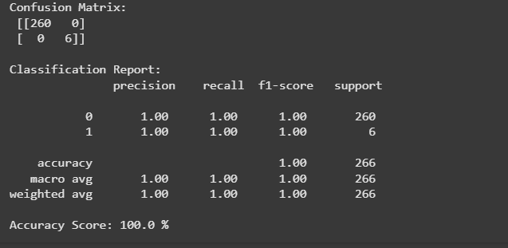
 | Tune the Model | Hyperparameter Tuning -  Validation Method -

